NEW COPRORATE PARTNERSHIP TO HELP BAMBOOIN BOLIVIA

Sakroots® is a lifestyle accessories brand that expresses the artist, musician and nature lover in all of us. Each print collection features original artwork from the Sakroots Artist Circle gallery of artists. Their Bambu print is by Mexican artist Jetro Martinez. The print reflects the philosophy of peace and harmony among all things and depicts bamboo in a biodiverse setting, as it grows in nature. The collection of products are sold in better department stores across the United States, as well as from their website, www.sakroots.com.
The company is partnering with like-minded charitable organizations, tying each organization to one of the artist circle prints. The bamboo print led to the partnership with the World Bamboo Organization.
World Bamboo is all about the global exchange of environmental, socioeconomic, biological, botanical and cultural aspects of bamboo. By bringing together bamboo people, our goal is to provide new partnerships and alliances to advance the efforts of bamboo knowledge. Bamboo plays a diverse and vital role in a wide range of markets – both traditional and newly emerging – relating to housing and household materials, consumer products, alternative energies, environmental remediation, medicine, nutrition and climate mitigation.
Alternatively, WBO identified the Fundacion Amigos de la Naturaleza (http://www.fan-bo.org) to be the sole recipient of the corporate sponsorship, which will come directly from a percentage of the purchase price of each Bambu print Sakroots products. The global publicity and promotion of both of our mutual missions will benefit greatly from this partnership.

About Fundación Amigos de la Naturaleza
Fundación Amigos de la Naturaleza (FAN) is a non-profit non-governmental organization that has been dedicated to the conservation of biodiversity in Bolivia for more than 20 years. The organization’s work is characterized as science- based, technically viable, socially participatory, and administratively transparent. Its mission is to generate opportunities and innovation for the conservation of biodiversity in Bolivia.
Since 2005, together with local communities, the public and private sector, FAN is the main player driving the national development of “sustainable bio- trade”, a strategy that allows for economic development needs to be met in conservation areas without harming biodiversity. FAN is recognized nationally and internationally for developing and employing a wide range of tools for biodiversity conservation in Bolivia that allow for more efficient and targeted interventions.
Although bamboo can be found in the wild and be used as a renewable, reliable material, it’s rarely used in Bolivia. In 2010 Bolivian bamboo exports add to a value of U.S. $ 4,355. The products manufactured in the country range from handmade baskets, musical instruments, flutes and panpipes, rustic furniture and decorative items for home. These products are elaborated and commercialized in a local and not very dynamic market. Indigenous and peasant communities -especially the ones located on Guarayos, Ibañez and Ichilo provinces in Santa Cruz department- collect it from the wilderness and use it in traditional ways as the main material of construction of their homes. The local producers, indigenous or peasant, of the three provinces mentioned above, have a basic knowledge of bamboos versatility and its capacity to be transformed and introduced into the national market. Some of these initiatives apply sustainable management practices in the recollection and handling required by the product, but they lack knowledge when it comes to the preservation of the species in its habitat, and processes required achieving of higher quality for differentiated markets.
The alternatives and diversified potential uses of bamboo in Bolivia are vast. The Bolivian Amazon basin contains several species of it and they are widely distributed across the region, which makes it an abundant resource, but in practice it is highly underused. The potential to utilize this resource with a focus on bio-trade (processing, transformation and commercialization practices under environmental, social and economic sustainability criteria) are being missed. There are successful experiences in Bolivia with non-timber forest products, where peasant and indigenous communities have achieved an improvement in their livelihoods. Wild bamboo has potential to become another one.
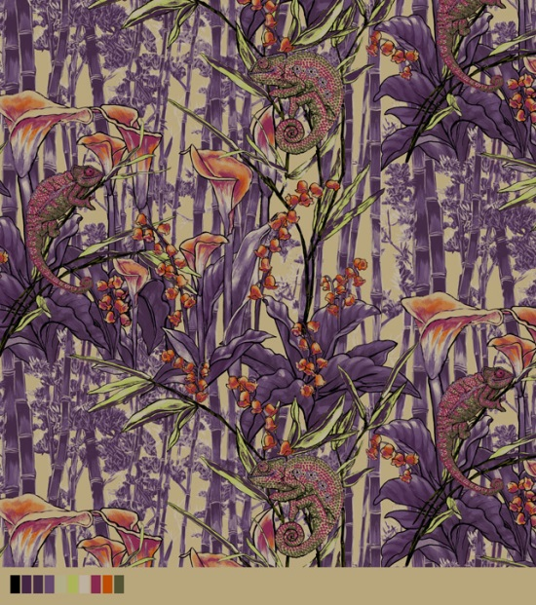World Bamboo Organization and Sakroots will work to raise funds for FAN to enhance and boost the sustainable use of bamboo for construction. The aim is to work in rural indigenous and peasant communities in Ascension de Guarayos, Buena Vista and Porongo municipalities of the Department of Santa Cruz. The bio-trade approach, conservation of biodiversity, sustainable use of natural resources and fair and equitable benefit sharing along the supply chain, is the core of the proposal.
We encourage you to purchase Sakroots Bambu print products! Check out the website, and do some shopping! We hope this simple beginning of corporate partnerships helps not only to bring sustainable bamboo products to the market, but helps promote biological conservation, bolster traditional utilization by indigenous peoples, and promote sustainable bamboo development around the world

[Article taken from www.worldbamboo.net … Dt. March 18, 2013]
***************************

